February 2, 2024

Evan Olsen (RIT Student)

RIT Liquid propulsion

FACTOR OF SAFETY CALCULATION

COMBUSTION CHAMBER SUB-TEAM

*Figure #1: 0.1[in] Wall, 3[s] Burn*

*Figure #2: 0.1[in] Wall, 6[s] Burn*

*Figure #3: 0.15[in] Wall, 3[s] Burn*

*Figure #4: 0.15[in] Wall, 6[s] Burn*

*Figure #5: 0.2[in] Wall, 3[s] Burn*

*Figure #6: 0.2[in] Wall, 6[s] Burn*

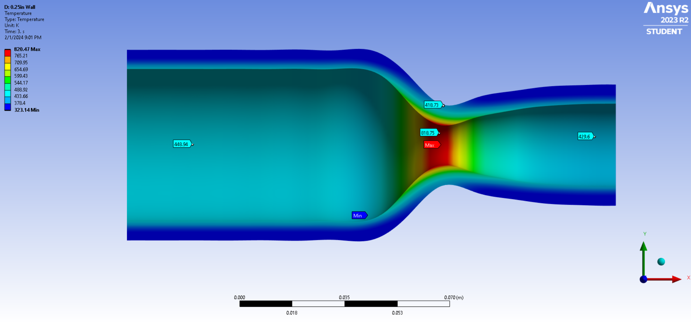

*Figure #7: 0.25[in] Wall, 3[s] Burn*

*Figure #8: 0.25[in] Wall, 6[s] Burn*

*Figure #9: 0.3[in] Wall, 3[s] Burn*

*Figure #10: 0.3[in] Wall, 6[s] Burn*

|  |  |  |  |  |  |  |
| --- | --- | --- | --- | --- | --- | --- |
|  | Wall Thickness | | | | | |
| Burn Time |  | 0.10 [in] | 0.15 [in] | 0.20 [in] | 0.25 [in] | 0.30 [in] |
| 3 [s] | Chamber – 4.9  Throat – 36.7 | Chamber – 9.9  Throat – 50.4 | Chamber – 11.4  Throat – 84.0 | Chamber – 15.0  Throat – 112.9 | Chamber – 18.3  Throat – 154.0 |
| 6 [s] | Chamber – 4.4  Throat – 30.9 | Chamber – 9.0  Throat – 34.1 | Chamber – 9.6  Throat – 82.2 | Chamber – 13.1  Throat – 99.8 | Chamber – 16.5  Throat – 131.1 |

*Table #1: FOS for Given Wall Thickness & Burn Time*

*Figure #11: FOS vs. Wall Thickness for Burn Time*

**0.1[in] Thickness, 3[s] Burn Time**

**0.1[in] Thickness, 6[s] Burn Time**

**0.15[in] Thickness, 3[s] Burn Time**

**0.15[in] Thickness, 6[s] Burn Time**

**0.2[in] Thickness, 3[s] Burn Time**

**0.2[in] Thickness, 6[s] Burn Time**

**0.25[in] Thickness, 3[s] Burn Time**

**0.25[in] Thickness, 6[s] Burn Time**

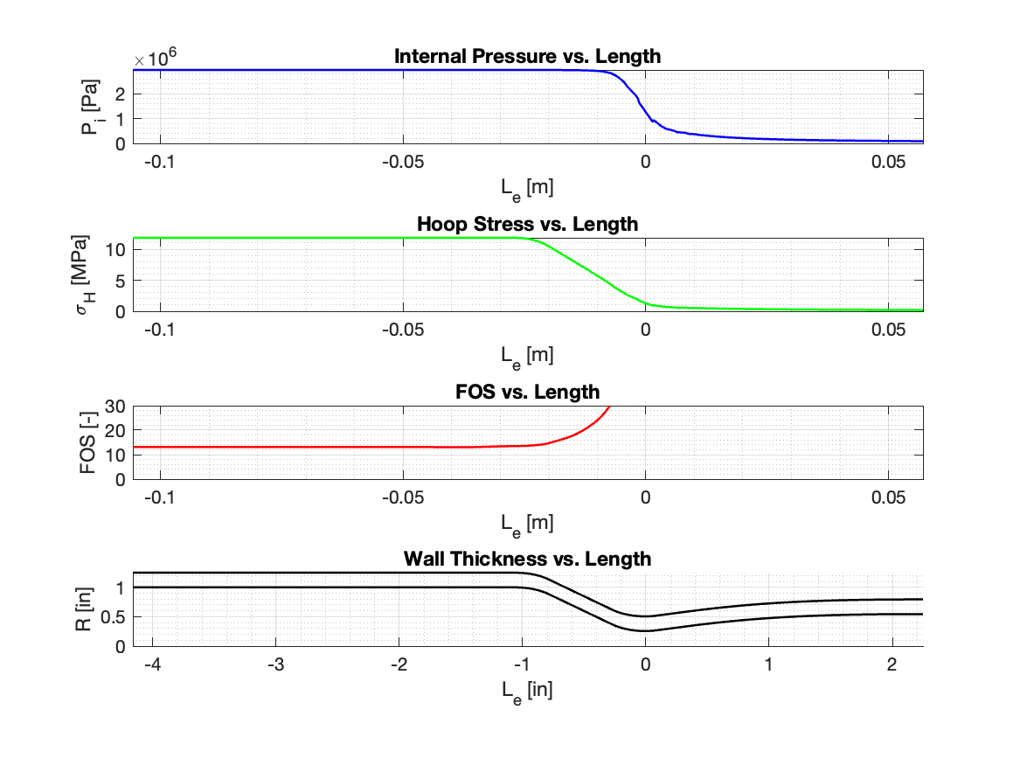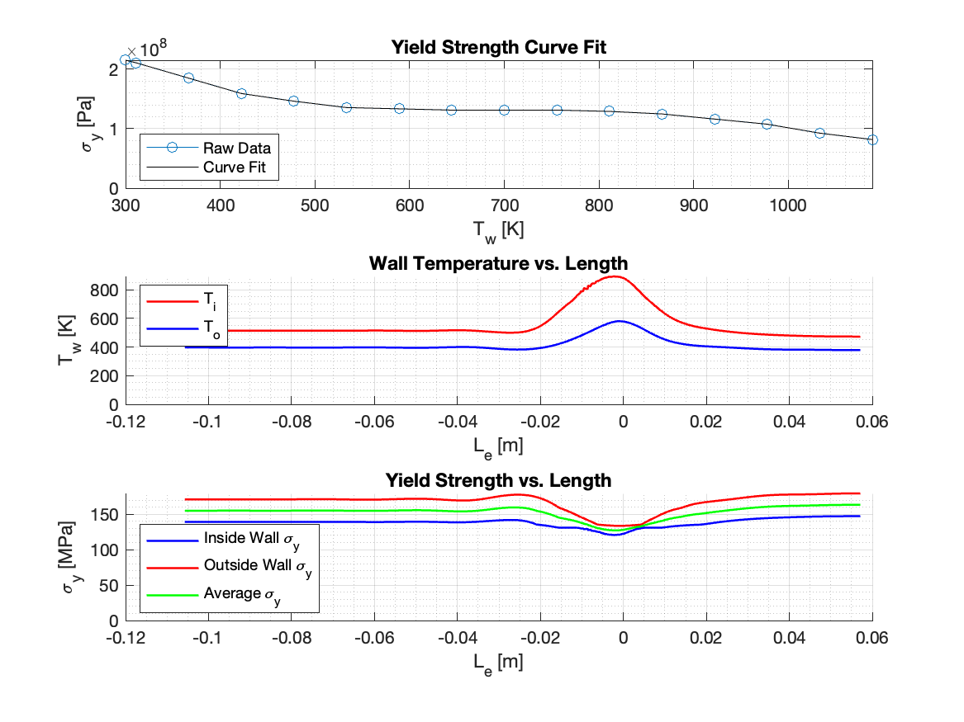

**0.3[in] Thickness, 3[s] Burn Time**

**0.3[in] Thickness, 6[s] Burn Time**

*\*All raw data can be found on the Launch Initiative GitHub under the calc-factor-of-safety repository*